Kubernetes Task-5
- Create a namespace dev-environment and apply a resource-based quota that restricts the number of pods to 3 and services to 2.
- Create a pod in the prod-environment namespace with 0.2 CPU and 200Mi memory requests, and 0.5 CPU and 500Mi memory limits.
- In the staging-environment namespace, set a Limit Range that assigns default CPU and memory limits (300m CPU, 600Mi memory) and applies a minimum and maximum CPU.
- Create a pod and a Node Port service in the default namespace, then create another pod in the test namespace and communicate between them using Service DNS.
- Apply a Limit Range with a max limit/request ratio of 2 for memory in the performance-environment namespace, and test by creating a pod with mismatched resource requests and limits.

  - Vi dev-environment-quota.yaml
apiVersion: v1
kind: Namespace
metadata:
name: dev-environment
---
apiVersion: v1
kind: ResourceQuota
metadata:
name: dev-quota
namespace: dev-environment
spec:
hard:
pods: "3"
services: "2"

kubectl apply -f dev-environment-quota.yaml
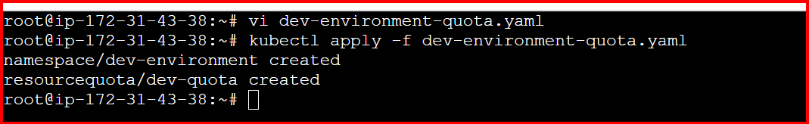
Kubectl get ns
kubectl get resourcequota -n dev-environment
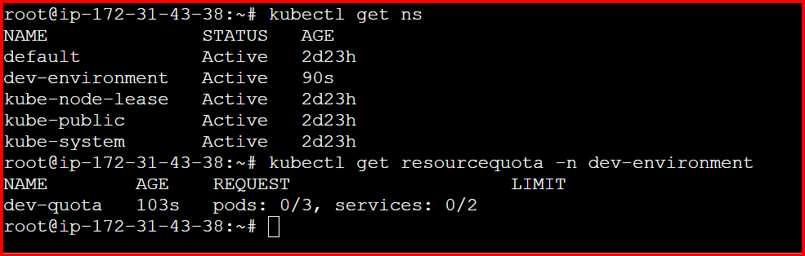
kubectl describe resourcequota dev-quota -n dev-environment
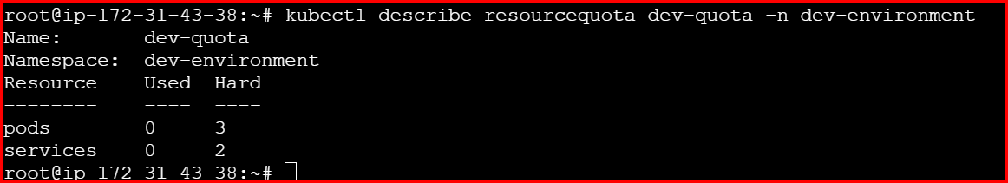
Vi test-pods.yaml

apiVersion: v1
kind: Pod
metadata:
name: pod1
namespace: dev-environment
spec:
containers:
- name: nginx
image: nginx
---
apiVersion: v1
kind: Pod
metadata:
name: pod2
namespace: dev-environment
spec:
containers:
- name: nginx
image: nginx
---
apiVersion: v1
kind: Pod
metadata:
name: pod3
namespace: dev-environment
spec:
containers:
- name: nginx
image: nginx
kubectl apply -f test-pods.yaml
kubectl get pods -n dev-environment
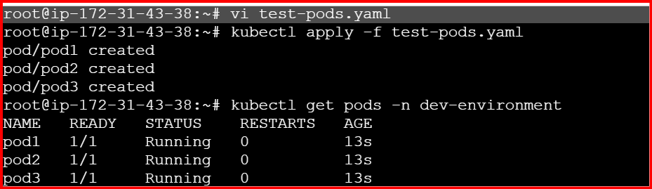

Try creating a 4th pod (should fail)
Create a 4th pod manually:
kubectl run pod4 --image=nginx -n dev-environment
kubectl describe resourcequota dev-quota -n dev-environment
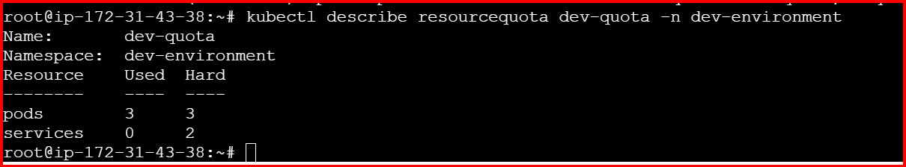

2.
apiVersion: v1
kind: Namespace
metadata:
name: prod-environment
---
apiVersion: v1
kind: Pod
metadata:
name: prod-pod
namespace: prod-environment
spec:
containers:
- name: nginx
image: nginx:latest
resources:
requests:
cpu: "200m" # 0.2 CPU
memory: "200Mi" # 200 MiB memory
limits:
cpu: "500m" # 0.5 CPU
memory: "500Mi" # 500 MiB memory

Apply the configuration
kubectl apply -f prod-environment-pod.yaml
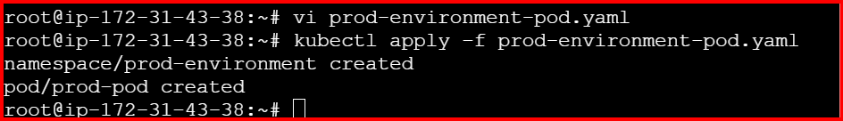

verify the Pod and Resource Configuration
Check pod status:
kubectl get pods -n prod-environment
kubectl describe pod prod-pod -n prod-environment

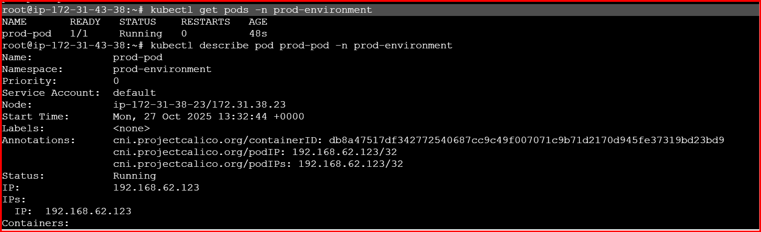
3.
Vi staging-limitrange.yaml
apiVersion: v1
kind: Namespace
metadata:
name: staging-environment
---
apiVersion: v1
kind: LimitRange
metadata:
name: staging-limits
namespace: staging-environment
spec:
limits:
- type: Container
default:
cpu: "300m" # Default CPU limit
memory: "600Mi" # Default Memory limit
defaultRequest:
cpu: "200m" # Default CPU request
memory: "400Mi" # Default Memory request
min:
cpu: "100m" # Minimum CPU
memory: "200Mi" # Minimum memory (optional, but added for balance)
max:
cpu: "500m" # Maximum CPU
memory: "1Gi" # Maximum memory (optional)

kubectl apply -f staging-limitrange.yaml
Check that the LimitRange was created:
kubectl get limitrange -n staging-environment
To see full details:
kubectl describe limitrange staging-limits -n staging-environment
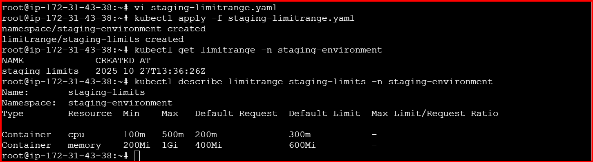
4.
vi default-test-communication.yaml
1. Pod in default namespace
# --- 1. Pod in default namespace ---
apiVersion: v1
kind: Pod
metadata:
name: web-pod
namespace: default
labels:
app: web
spec:
containers:
- name: nginx
image: nginx:latest
ports:
- containerPort: 80

---
# --- 2. NodePort Service in default namespace ---
apiVersion: v1
kind: Service
metadata:
name: web-service
namespace: default
spec:
type: NodePort
selector:
app: web
ports:
- port: 80
targetPort: 80
nodePort: 30080 # You can choose any port between 30000–32767

---
# --- 3. Pod in test namespace ---
apiVersion: v1
kind: Namespace
metadata:
name: test
---
apiVersion: v1
kind: Pod
metadata:
name: client-pod
namespace: test
spec:
containers:
- name: curl
image: curlimages/curl:latest
command: ["sleep", "3600"]

kubectl apply -f default-test-communication.yaml
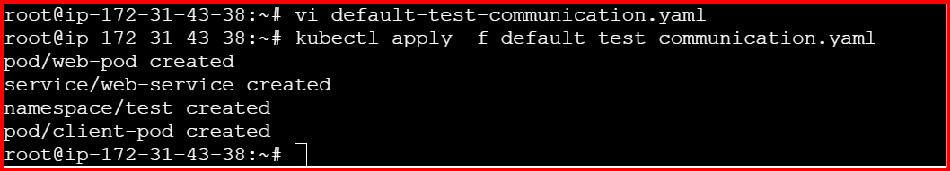
Wait for pods to be running:
kubectl get pods -n default
kubectl get pods -n test
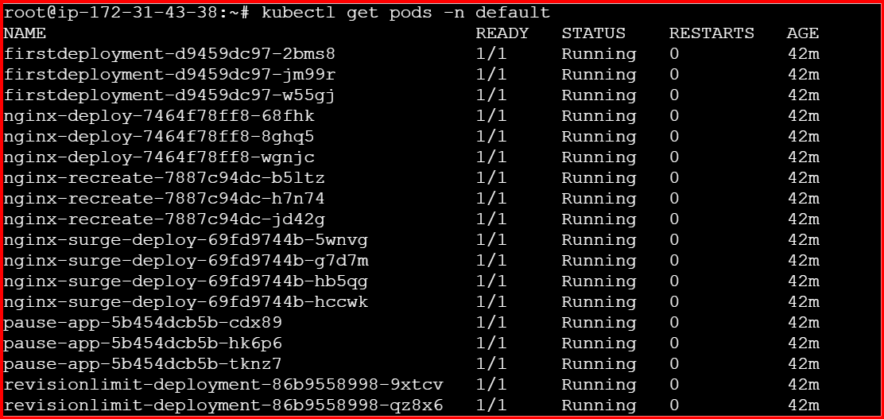
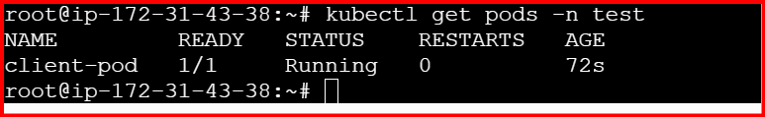
Kubernetes services can be reached via this DNS pattern:
Run this command to test communication from the test namespace pod:
You should get an HTML response from nginx
kubectl exec -n test client-pod -- curl web-service.default.svc.cluster.local
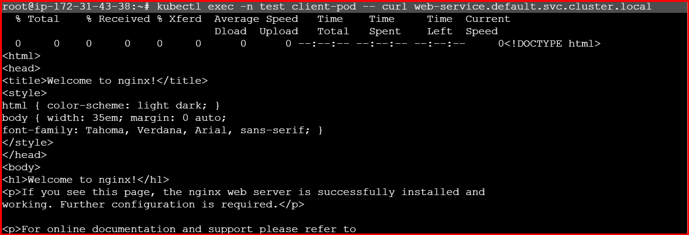

5.
vi performance-limitrange.yaml
apiVersion: v1
kind: Namespace
metadata:
name: performance-environment
---
apiVersion: v1
kind: LimitRange
metadata:
name: performance-limits
namespace: performance-environment
spec:
limits:
- type: Container
maxLimitRequestRatio:
memory: 2

Apply the LimitRange
kubectl apply -f performance-limitrange.yaml
Verify it:
kubectl describe limitrange performance-limits -n performance-environment

